FACULTY OF CHEMICAL AND METALLURGICAL ENGINEERING
DEPARTMENT OF BIOENGINEERING

THESIS TEMPLATE
(Based on the thesis template of Graduate School of Natural And Applied Sciences)

FEBRUARY, 2018

REPUBLIC OF TURKEY
YILDIZ TECHNICAL UNIVERSITY
FACULTY OF CHEMICAL AND METALLURGICAL ENGINEERING

LOCATION ANALYSIS OF THE EMERGENCY SERVICE
CENTERS OF A CASE COMPANY

MELTEM YETKİN
1805A095

GRADUATION THESIS
DEPARTMENT OF BIOENGINEERING

ADVISER
PROF. DR. SALİM YÜCE

İSTANBUL, 2018

REPUBLIC OF TURKEY
YILDIZ TECHNICAL UNIVERSITY
FACULTY OF CHEMICAL AND METALLURGICAL ENGINEERING

LOCATION ANALYSIS OF THE EMERGENCY SERVICE CENTERS OF A CASE COMPANY

This GRADUATION THESIS submitted by Meltem YETKİN is approved by the committee on 01.03.2013 in Yildiz Technical University, Faculty of Chemical and Metallurgical Engineering, Department of Bioengineering.

Thesis Adviser
Prof. Dr. Salim YÜCE
Yıldız Technical University

Approved By the Examining Committee
Prof. Dr. Salim YÜCE (rewrite your adviser’s name )
Yıldız Technical University _____________________

Prof. Dr. Faruk YİĞİT, Member (second member of the committee)
Yıldız Technical University _____________________

Assist. Prof. Dr. Salim YÜCE, Member (third member of the committee)
İstanbul University _____________________

I declare that, my thesis does not include any form of plagiarism according to the maximum similarity index values specified in the Yıldız Technical University Graduate School of Natural and Applied Sciences Guidelines for Thesis Originality Reports; that in any future detection of possible infringement of the regulations I accept all legal responsibility; and that all the student information provided below is correct to the best of my knowledge.

Student’s Name-Surname
…./…./20…
Signature

ACKNOWLEDGEMENTS

Yıldız Technical University is one of the seven government universities situated in İstanbul besides being the 3rd oldest university of Turkey with its history dating back to 1911.It is regarded as one of the best universities in the country as well. Our university has 10 Faculties, 2 Institutes, the Vocational School of Higher Education, the Vocational School for National Palaces and Historical Buildings, the Vocational School for Foreign Languages and more than 25,000 students.

The Istanbul State Engineering and Architectural Academy and affiliated schools of engineering and the related faculties and departments of the Kocaeli State Engineering and Architecture Academy and the Kocaeli Vocational School were merged to form Yıldız University with decree law no.41 dated 20 June 1982 and Law no. 2809 dated 30 March 1982 which accepted the decree law with changes.
The new university incorporated the departments of Science-Literature and Engineering, the Vocational School in Kocaeli, a Science Institute, a Social Sciences Institute and the Foreign Languages, Atatürk Principles and the History of Revolution, Turkish Language, Physical Education and Fine Arts departments affiliated with the Rectorate.

Yıldız Technical University is one of the seven government universities situated in İstanbul besides being the 3rd oldest university of Turkey with its history dating back to 1911.It is regarded as one of the best universities in the country as well.

March, 2013

Meltem YETKİN

TABLE OF CONTENTS
Page
LIST OF SYMBOLS vii
LIST OF ABBREVIATIONS viii
LIST OF FIGURES ix
LIST OF TABLES x
ABSTRACT xi
ÖZET xiii
CHAPTER 1
INTRODUCTION 1
1.1 Literature Review 1
1.2 Objective of the Thesis 1
1.3 Hypothesis 1
CHAPTER 2
GENERAL INFORMATION 3
2.1 History 4
2.2 Historical Advancements in the University 5
2.2.1 The Yıldız University Period 5
2.2.2 The Yıldız Technical University Period 5
CHAPTER 3
ERASMUS 7
3.1 National Agency 8
3.2 About YTU 8
3.3 Application Procedure 10
3.4 Money Exchange 10
3.5 After a Car Accident 11

CHAPTER 4
RESULTS AND DISCUSSION 13
REFERENCES 14
APPENDIX-A
ERASMUS POLICY 15
APPENDIX-B
ERASMUS COUNTRY CODES 16
CURRICULUM VITAE 18

LIST OF SYMBOLS

Ai Meeting point
c Index of quality
C Set of quality
CR Critical ratio
ƒc(.) Opportunity cost of c
ΔH The length of time period
λi Length of truck-i
Ω Set of trucks

LIST OF ABBREVIATIONS

CIBSE The Chartered Institution of Building Services Engineers
CIE Commission Internationale de L’éclairage
IEEE Institute of Electrical and Electronics Engineers
IES The Illuminating Engineering Society of North America
LiTG Lichttechnische Gesellschaft e.V. (Bundesrepublik Deutschland)
LTAG Österreichische Lichttechnische Arbeitsgemeinschaft
SLG Schweizerische Lichttechnische Gesellschaft
YTU Yıldız Technical University

LIST OF FIGURES
Page
Figure 2.1 Landscape design of Yıldız Technical University 3
Figure 2.2 The Istanbul Technical School 4
Figure 2.3 Side view of Graduate School of Natural and Applied Sciences, Yıldız Technical University, Çukursaray, İstanbul 6

LIST OF TABLES
Page
Table 3.1 Erasmus country codes for different national agencies according to the type of the countries…………………………………………………….....8
Table 3.2 Area codes for different subjects…………………………………………10
Table B.1 Area codes for different subjects………………….………………..…….15
Table B.2 Abbreviations for different countries……………..…………………...…16

ABSTRACT
LOCATIONAL ANALYSIS OF EMERGENCY SERVICE CENTERS OF A CASE COMPANY

Meltem YETKİN

Department of Bioengineering
B.Eng. Graduation Thesis

Adviser: Prof. Dr. Salim YÜCE

In view of today’s economic conditions chemical processes are operated or designed on the basis of optimum energy consumption. Thus primarily heat integration studies are undertaken and the design of the heat exchanger networks has entered into a new phase with the introduction of the pinch-point concept.
In this study, it is aimed at designing heat exchanger networks by the use of pinch-point design method, which is one of the significant heat integration methods. In the presentation of the work various theoretical approaches regarding the pinch-point design method are discussed, and a new “Improved Problem Algorithm Table” developed for the application of the design is introduced. Taking into account the scope of design in actual processes Visual Basic 3.0 programming language is used to develop the computer code called DarboTEK. This computer code can be used both in determining the minimum energy and area targets of a new plant to be constructed, and in making necessary design alterations in an already existing plant.
The crude petroleum unit in the TÜPRAŞ refinery at İzmit has been selected to show the applicability of the computer code developed to a real process, and as a result an original application has been accomplished. The heat integration study carried out on the crude petroleum unit shows that if a capital of 3576627 $ is invested, the investment payback period is 1.7 years on the basis of the energy conservation achieved. Investment need is high; it is significant that it can be paid back by energy conservation in a reasonable period of time.
The crude petroleum unit in the TÜPRAŞ refinery at İzmit has been selected to show the applicability of the computer code developed to a real process, and as a result an original application has been accomplished. The heat integration study carried out on the crude petroleum unit shows that if a capital of 3576627 $ is invested, the investment payback period is 1.7 years on the basis of the energy conservation achieved. Investment need is high; it is significant that it can be paid back by energy conservation in a reasonable period of time.
The crude petroleum unit in the TÜPRAŞ refinery at İzmit has been selected to show the applicability of the computer code developed to a real process, and as a result an original application has been accomplished. In this study, it is aimed at designing heat exchanger networks by the use of pinch-point design method, which is one of the significant heat integration methods. In the presentation of the work various theoretical approaches regarding the pinch-point design method are discussed, and a new “Improved Problem Algorithm Table” developed for the application of the design is introduced.
Key words: Railway traffic control, conflicts between trains, re-scheduling, genetic algorithms, neural networks

YILDIZ TECHNICAL UNIVERSITY
FACULTY OF CHEMICAL AND METALLURGICAL ENGINEERING

ÖZET

VAKA ŞİRKETİNDE ACİL SERVİS MERKEZLERİNİN LOKASYONLARININ ANALİZİ

Meltem YETKİN

Biyomühendislik Bölümü
Bitirme Tezi

Tez Danışmanı: Prof. Dr. Salim YÜCE

Ulaştırma alt sistemlerinden biri olan demiryolu, diğer ulaştırma alt sistemleriyle yoğun bir rekabet halinde bulunmaktadır. Yürütüle gelen yanlış politikalar sonucu ülkemizde demiryolu ulaştırmasına olan talep, yolcu ve yük taşımacılığında karayolunun oldukça gerisinde kalmıştır. Demiryolunun pazar payını arttırması ve rekabetini devam ettirebilmesi için hizmet kalitesini arttırması gerekmektedir. Dakiklik ve güvenilirlik bir ulaştırma alt sisteminin kalitesini belirleyen ölçütlerin başında gelmektedir. Bu ölçütlerin istenilen seviyede tutulabilmesi de kısmen etkin trafik kontrolü ile sağlanabilir.
Trenler önceden hazırlanmış bir hareket planına uygun biçimde hareket etmektedir. Ancak beklenmedik bazı olayların gerçekleşmesi sonucu gecikmeler ve dolayısıyla trenler arası çatışmalar meydana gelebilmektedir. Trafik kontrolü, trenler arası çatışmaları, gecikmeleri mümkün olduğunca azaltacak şekilde çözüp, yeni bir uygulanabilir çizelge hazırlamak için uygulanır. Problemin zorluk derecesi nedeniyle, problemin en az gecikme içeren çözümüne kabul edilebilir bir süre içerisinde ulaşılması imkânsızdır. Bu çalışmada, 5 dakika gibi kısa bir süre içerisinde uygulanabilir ve gecikme toplamının olabildiğince küçüklendiği bir çizelge hazırlamak için, genetik algoritmalar kullanılmıştır. Geliştirilen algoritmanın çözümleri, belirli boyuttaki problemlerin kesin ve dispeçer çözümleri (yapay sinir ağı) ile karşılaştırıldığında, algoritma kısa sürede yeteri kadar iyi sonuçlar vermektedir. Algoritmanın uygulanması için geliştirilen bilgisayar programı, tren dispeçerleri için bir karar destek sistemi olarak da kullanılabilir.
Trenler önceden hazırlanmış bir hareket planına uygun biçimde hareket etmektedir. Ancak beklenmedik bazı olayların gerçekleşmesi sonucu gecikmeler ve dolayısıyla trenler arası çatışmalar meydana gelebilmektedir. Trafik kontrolü, trenler arası çatışmaları, gecikmeleri mümkün olduğunca azaltacak şekilde çözüp, yeni bir uygulanabilir çizelge hazırlamak için uygulanır. Problemin zorluk derecesi nedeniyle, problemin en az gecikme içeren çözümüne kabul edilebilir bir süre içerisinde ulaşılması imkânsızdır. Bu çalışmada, 5 dakika gibi kısa bir süre içerisinde uygulanabilir ve gecikme toplamının olabildiğince en küçüklendiği bir çizelge hazırlamak için, genetik algoritmalar kullanılmıştır. Geliştirilen algoritmanın çözümleri, belirli boyuttaki problemlerin kesin ve dispeçer çözümleri (yapay sinir ağı) ile karşılaştırıldığında, algoritma kısa sürede yeteri kadar iyi sonuçlar vermektedir. Algoritmanın uygulanması için geliştirilen bilgisayar programı, tren dispeçerleri için bir karar destek sistemi olarak da kullanılabilir.
Anahtar Kelimeler: Demiryolu trafik kontrolü, trenlerarası çatışmalar, yeniden çizelgeleme, genetik algoritmalar, yapay sinir ağları

YILDIZ TEKNİK ÜNİVERSİTESİ KİMYA-METALÜRJİ FAKÜLTESİ

CHAPTER 1

INTRODUCTION

Literature Review
Istanbul is a beautiful city of stunning architecture, history and culture. You'll find ancient and modern colleges, fascinating museums and galleries, and plenty of parks, gardens and green spaces in which to relax [1]. Although the city is spread over a large area, you will have easy reach to anywhere you would like to go thanks to a variety of modern and developed transportation systems diversing from interchangeable rail systems to long-way metrobus lines [2].

Objective of the Thesis
There are two airports in Istanbul. Atatürk Airport is on the European Side of the city, and Sabiha Gökçen Airport is on the Asian Side. As both of the airports are located outside the city centre you may find the taxi fees fairly expensive. The taxi from Atatürk Airport to Yıldız Central Campus will cost around Euro 35-40. In case you arrive at the Sabiha Gökçen Airport, you will need to pay double this amount to get here and you will also have to add the bridge fee to it. Communication with the taxi driver will be much easier if you write down the address and hand it to him [3].

Hypothesis
You may only use this method of transport from the Atatürk Airport. You can easily reach the station by following the “Metro” signs. If you have difficulties, you can easily ask airline staff for directions. In order to get on the metro, you need to buy a token from the counter [4]. You need to use this token to go through the turnstiles in order to get to the train. You can enjoy the journey without getting stressed as you will go from the first station the last station. You can easily come out at the Aksaray Station, the last station, by following the signs [5]. We suggest you get a taxi from here. Your location is not too close to Yıldız Central Campus but it is also not too far. The taxi from here will cost approx. Euro15 [2].

CHAPTER 2

GENERAL INFORMATION
Istanbul is a beautiful city of stunning architecture, history and culture. You'll find ancient and modern colleges, fascinating museums and galleries, and plenty of parks, gardens and green spaces in which to relax [6]. Although the city is spread over a large area, you will have easy reach to anywhere you would like to go thanks to a variety of modern and developed transportation systems as well as interchangeable rail systems to long-way metrobus lines.
In Figure 2.1, landscape design of Yıldız Technical University is illustrated. The side view of the garden can be seen from Figure 2.1.
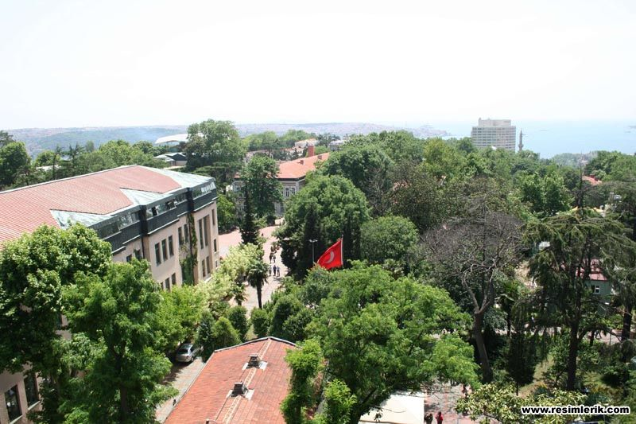
Figure 2.1 Landscape design of Yıldız Technical University

History
The stages our university has passed through in its distinguished past are outlined below. Kondüktör Mekteb-i Âlisi/ The Conductors (Technicians) School of Higher Education (1911-1922). The Kondüktör Mekteb-i Âlisi/Conductors (Technicians) School of Higher Education was founded in 1911 in order to meet the “science officer” (known previously as conductors, and today as technicians) requirement of the Municipality Public Works Section. The school was modeled on the syllabus of the “Ecole de Conducteur” and was affiliated with the Ministry of Public Works. Enrolment began on 22 August 1911 [7].
Nafia Fen Mektebi/ The School of Public Works (1922-1937): The school’s name was changed to Nafia Fen Mektebi/ School of Public Works in 1922 and the duration of education was increased to 2.5 years in 1926 and 3 years in 1931.
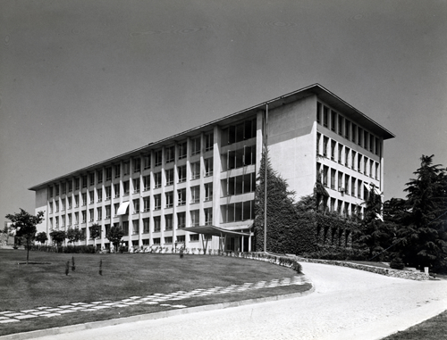
Figure 2.2 The Istanbul Technical School

Historical Advancements in the University

The school was established as an autonomous higher education and research institution with Law no. 1184 of State Engineering and Architectural Academies published on 3 June 1969.
Law no. 1472 ruled for the closing of special vocational schools in 1971, and engineering schools were affiliated with the Istanbul State Engineering and Architectural Academy.

The Yıldız University Period
The Istanbul State Engineering and Architectural Academy and affiliated schools of engineering and the related faculties and departments of the Kocaeli State Engineering and Architecture Academy and the Kocaeli Vocational School were merged to form Yıldız University with decree law no.41 dated 20 June 1982 and Law no. 2809 dated 30 March 1982 which accepted the decree law with changes [4].
The new university incorporated the departments of Science-Literature and Engineering, the Vocational School in Kocaeli, a Science Institute, a Social Sciences Institute and the Foreign Languages, Atatürk Principles and the History of Revolution, Turkish Language, Physical Education and Fine Arts departments affiliated with the Rectorate [8].

The Yıldız Technical University Period
Law no. 3837 dated 3 July 1992 renamed our university Yıldız Technical University. The Engineering Faculty was divided into four faculties and restructured as the Electrical-Electronics, Construction, Mechanical and Chemical-Metallurgy Faculties and also included the Faculty of Economics and Administrative Sciences within its organization. The Kocaeli Faculty of Engineering and the Kocaeli Vocational School were released from our university to be restructured as Kocaeli University. Today our university has 9 Faculties, 2 Institutes, the Vocational School of Higher Education, the Vocational School for National Palaces and Historical Buildings, the Vocational School for Foreign Languages and more than 20,000 students [9].

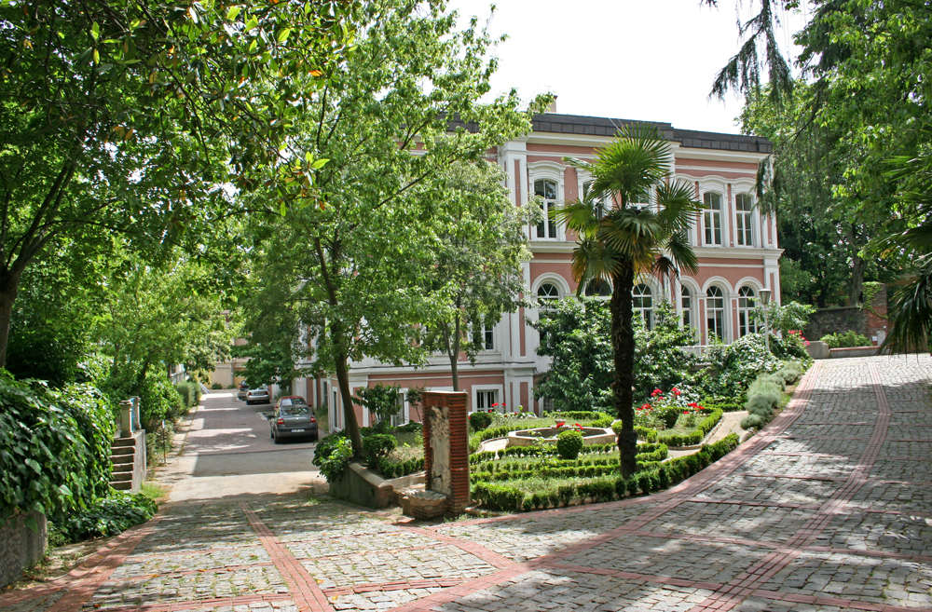
Figure 2.3 Side view of Graduate School of Natural and Applied Sciences, Yıldız Technical University, Çukursaray, İstanbul [10]

Mission
Our mission is to create a university which pioneers education, scientific research, technological development and artistic work aimed at the progress of society and the increase of the quality of life within an understanding of national and international solidarity; and educates creative, enterprising, questioning and ethical students equipped with universal values, who constantly renew themselves, aim for lifelong learning and are capable of analysis and synthesis.
(2.1)
(2.2)
(2.3)
(2.4)

CHAPTER 3

ERASMUS
ERASMUS is the EU's flagship education and training program enabling 200 000 students to study and work abroad each year. In addition, it funds co-operation between higher education institutions across Europe. The program supports not only students, but also professors and business staffs who want to teach abroad, as well as helping university staff to receive training.
ERASMUS seeks to enhance the quality and reinforce the European dimension of higher education by encouraging transnational cooperation between universities, boosting European mobility and improving the transparency and full academic recognition of studies and qualifications throughout the Union.
ERASMUS consists of many different activities; student and teacher exchanges, joint development of study program (Curriculum Development), international intensive programs, thematic networks between departments and faculties across Europe, language courses (EILC), European credit transfer system (ECTS) [11].
ERASMUS action is targeted at higher education institutions and their students and staff in all 27 Member States of the European Union, the three countries of the European Economic Area (Iceland, Liechtenstein and Norway), and Turkey.
Currently 2199 higher education institutions in 31 countries are participating in Erasmus. Since the creation of Erasmus in 1987, 1.2 million students have benefited from an Erasmus study period abroad. The Erasmus budget for the year 2004 is more than € 187.5 million.

National Agency
Generally, National Agencies are founded in the participatory countries so as to utilize EU Education and Youth programs by organizing and coordinating activities in cooperation with the relevant parties.
National Agency, a part of State Planning Agency, is responsible for the coordination of the European Union Education Programs in Turkey.

About YTU
Yıldız Technical University is one of the seven government universities situated in İstanbul besides being the 3rd oldest university of Turkey with its history dating back to 1911.It is regarded as one of the best universities in the country as well. Our university has 10 Faculties, 2 Institutes, the Vocational School of Higher Education, the Vocational School for National Palaces and Historical Buildings, the Vocational School for Foreign Languages and more than 25,000 students [9].
As YTU our mission is to create a university which pioneers education, scientific research, technological development and artistic work aimed at the progress of society and the increase of the quality of life within an understanding of national and international solidarity
Table 3.1 Erasmus country codes for different national agencies according to the type of the countries
No. | National Agencies | Erasmus Code | ISO Code | NA Identifier | Type of Country
1 | Austria | A | AT | AT | EU
2 | Belgium (Flemish speaking) | B | BE | BEFL | EU
3 | Belgium (French speaking) | B | BE | BEFR | EU
4 | Bulgaria | BG | BG | BG | Candidate
5 | Czech Republic | CZ | CZ | CZ | EU
Table 3.1 (cont’d)
6 | Cyprus | CY | CY | CY | EU
7 | Denmark | DK | DK | DK | EU
8 | Estonia | EE | EE | EE | EU
9 | Germany | D | DE | DE | EU
10 | Spain | E | ES | ES | EU
11 | Finland | SF | FI | FI | EU
12 | France | F | FR | FR | EU
13 | Greece | G | GR | GR | EU
14 | Hungary | HU | HU | HU | EU
15 | Iceland | IS | IS | IS | EEA
16 | Ireland | IRL | IE | IE | EU
17 | Italy | I | IT | IT | EU
18 | Latvia | LV | LV | LV | EU
19 | Liechtenstein | FL | LI | LI | EEA
20 | Lithuania | LT | LT | LT | EU
21 | Luxembourg | LUX | LU | LU | EU
22 | Malta | MT | MT | MT | EU
23 | Netherlands | NL | NL | NL | EU
24 | Norway | N | NO | NO | EEA
25 | Poland | PL | PL | PL | EU
26 | Portugal | P | PT | PT | EU
27 | Romania | RO | RO | RO | Candidate
28 | Slovak Republic | SK | SK | SK | EU
29 | Slovenia | SI | SI | SI | EU
30 | Sweden | S | SE | SE | EU

Application Procedure
You are expected to attach the following documents to the online application module.
- Application form
- Learning agreement
- Dormitory request form
- Signed documents
- ID Card

Money Exchange
The most convenient way to get money in Turkey is by using your home bank ATM/cash card or a credit card in a Turkish ATM/bancomat/cash machine [8].
Table 3.2 Area codes for different subjects
Area Code | Subject
1 | Agricultural sciences
2 | Culture
3 | Economics
4 | Technology
5 | Horticulture
6 | Fisheries
7 | Forestry
8 | Animal
9 | Tropical Agriculture
10 | Others
But if you want to exchange cash, plenty of places will do it for you. Currency Exchange Offices are found in tourist and market areas. They offer better exchange rates than most banks, and may or may not charge a commission. Offices in market areas tend to offer better exchange rates than those in tourist areas. Shop around for the best rate and the lowest (or no) commission.

After a Car Accident
The following is a step-by-step guide on what to do if you are involved in a traffic accident in Turkey.
From 1 April 2008 it is no longer necessary to call the police to the scene of an accident in the following circumstances:
- When - the accident involves two or more vehicles
- Where there is only material damage to vehicles
- When no one is injured or killed
Where all concerned parties agree to the cause and who is liable for the accident and providing each driver completes the correct form and all parties involved sign each form, including witnesses if any.
You should then submit the form to your insurance company who will use the form in conjunction with the other insurance companies concerned to settle liability. (For more details about how to access the form and instructions how to complete the form, please look at the end of this document.)
If agreement cannot be reached, you should immediately call 155 for Traffic Police assistance and follow the guide below:
Do Not Move Your Vehicle from the point of impact unless invited to do so by the traffic police or gendarme.
It is not advisable to accept an offer of financial settlement from the other parties involved. Wait for the police to arrive.
Once the police arrive, you will be breathalyses and asked to produce your driving license and logbook. A preliminary report of the accident will be compiled by the police at the scene of the accident. Only when this report has been made, should you move your vehicle. It can take half an hour for the police to arrive at the scene of an accident. Do not move your vehicle.
It is essential to obtain the result of the breathalyzer test and the official police report in order to make a successful insurance claim. You will be asked to collect this within three days from the District Police Station.
This leaflet has been prepared by the British Embassy in Ankara for the convenience of enquirers. Although all care has not been taken in its production, neither Her Majesty's Government nor any Consular Official in the British Embassy in Ankara takes any responsibility for its precise accuracy or for the consequences of any action taken in accordance with its contents [12].

CHAPTER 4

RESULTS AND DISCUSSION
Once you have opened this page you will either have to log in if you are already registered, or register if this is your first visit to this page. When you first register, an e-mail will be automatically sent to you confirming your registration and giving you your password. Once you have logged in you will be able to access the registration form, and you should enter all their details.
Please note that when you have entered your university code and the name of your department, only information which is relevant to your university and department, and which is covered by the relevant bilateral agreement will be displayed.
When you have completed the form, you will find at the bottom of the page a button called 'Attach Files'. This provides a link to where you can attach your completed university application form and Learning Agreement. If you have any special conditions or modifications to the Learning Agreement, you have to contact with your relevant departmental coordinator.
When you are finished, click 'Save' and then 'Send', in order the forms to be sent to this office. Once we have your completed forms we can pass them on to your coordinator here in Yıldız Technical University. Please note that The EU Office cannot make any changes to their form once it has been submitted. Once an understanding has been reached by the coordinators about their application, a Letter of Invitation will be prepared and sent to you.

REFERENCES
[1] Roth, J.P., (1966). “Diagnosis of Automata Failures: A Calculus and a Method”, IBM Journal of Research and Development, 10(1):278-291.
[2] Isdale, M. and Lee, Y.C., (1992). “An Object Oriented Modeling Framework for Geographic Information”, ISPRS XVII. Congress, 2-14 August 1992, Washington.
[3] R.T. Ministry of Environment and Forest General Directorate of Forestry , Main Tree Species, Forestry Policy, Legal and Institutional Frame Project, www.ogm.gov.tr, 11 March 2012.
[4] Gielsdorf, L. and Gründig, L., (1974). “Conformal Mapping of Local Coordinate Systems into a Global Reference Frame”, Second Turkish-German Joint Geodetic Days, 27-29 May 1974, Berlin, 185-194; Editor: Sidney, H.,A., (1997). Introduction to Physical Metallurgy, McGraw-Hill Book Co., New York.
[5] Sidney, H.A., (1974). Introduction to Physical Metallurgy, Second Edition, Mc Graw-Hill Book Co., New York.
[6] İşcan, P., (1992). Kent Bilgi Sistemine İlişkin Örnek Uygulamalar, MSc. Thesis, Yıldız Technical University, Graduate School of Natural and Applied Sciences, İstanbul.
[7] TSE 2478, (1976). Odunun Statik Eğilmede Elastikiyet Modülün Tayini, TSE, 1st Edition, Ankara.
[8] ASTM 907, (1982). Standard Definitions of Terms Relation to Adhesives, ASTM, Philadelphia.
[9] R.T. Ministry of Environment and Forest General Directorate of Forestry , Main Tree Species, www.ogm.gov.tr/agaclar.htm, 11 March 2012.
[10] Alkış, A., Isdale, M. and Sarbanoğlu, H., (1993). “Landinformationssystem in Türkei am Beispiel der Staadt Istanbul”, Proceedings of 16th Urban Data Management Symposium, 6–10 September 1993, Wien, 159–167.
[11] James, G.T. and Richards, A.P., Greenhouse Effect and Sea Level Rise: http://yosemite.epa.gov/oar/globalwarming.nsf/content/ResourceCenterPublicationsSLRCost_of_Holding.html, 21 March 2012.
[12] David, C.N. and Clifford, G.H., A Criteria and Indicators Approach to Development,http://sfm-1.biology.ualberta.ca/english/pubs/PDF/WP_2002 2.pdf, 21 March 2012

APPENDIX-A

ERASMUS POLICY
Yıldız Technical University is a major public comprehensive teaching and research university with high aspirations. It has devoted itself to a leading role in contributing through partnerships to socio-cultural and socioeconomic developments at the international level. It has had three years of experiences of participating in the ERASMUS program and its delivery of student and staff mobility has generally been above the national average for Turkey. We are also interested in the programs of LLP such as Comenius, Grundtvig, Leonardo da Vinci. We are going to consider organizing or participating in IP, CD or Thematic Network in the near future. Within the context of the Erasmus Program2007 – 2013, it is aimed to provide students, faculty and staff with more effective research, teaching, and service. With the Erasmus activities, we try to assess where we stood in the past, where we stand today and where we are going to stand in the future, comparing our current position with our peers. With respect to the objectives of the institutionalization of Erasmus student and staff mobility, we try to make our students and our academic staff benefit educationally, linguistically and culturally from the experience of learning in other European countries. We aim to mobilize 2.5 % of our students and 1.5% of teaching staff, by the year 2011. We will focus on the technical areas and near and new EU countries because of the exchanging our experiences.

APPENDIX-B

ERASMUS COUNTRY CODES
In Table B.1, the area codes for different subjects are listed. The first column of the Table B.1 shows the name of the country and the other columns are for the codes of these countries.
Table B.1 Area codes for different subjects
Country | Code 1 | Code 2 | Code 3 | Code 4
Cyprus | CY | CY | CY | EU
Denmark | DK | DK | DK | EU
Estonia | EE | EE | EE | EU
Germany | D | DE | DE | EU
Spain | E | ES | ES | EU
Finland | SF | FI | FI | EU
France | F | FR | FR | EU
Greece | G | GR | GR | EU
Hungary | HU | HU | HU | EU
Iceland | IS | IS | IS | EEA
Ireland | IRL | IE | IE | EU
Italy | I | IT | IT | EU
Latvia | LV | LV | LV | EU
Liechtenstein | FL | LI | LI | EEA

Table B.1 (cont’d)
Slovak Republic | SK | SK | SK | EU
Slovenia | SI | SI | SI | EU
Sweden | S | SE | SE | EU
United Kingdom | UK | UK | UK | EU
Turkey | TR | TR | TR | Candidate
Other | ---- | XX | ---- | Non-participating country

In Table B.2, the specific countries are illustrated for different codes.
Table B.2 Abbreviations for different countries
Latvia | LV | LV | LV | EU
Liechtenstein | FL | LI | LI | EEA
Lithuania | LT | LT | LT | EU
Luxembourg | LUX | LU | LU | EU
Malta | MT | MT | MT | EU
Netherlands | NL | NL | NL | EU

CURRICULUM VITAE

PERSONAL INFORMATION
Name Surname | : Surname should be written in capital letters
Date of birth and place | :
Foreign Languages | :
E-mail | :

EDUCATION
Degree | Department | University | Date of Graduation
Master | (If you don’t have master’s degree, please skip this line.)
Undergraduate
High School

WORK EXPERIENCE (If you don’t have any work experience, please skip this section.)
Year | Corporation/Institute | Enrollment
2010
2008
2002

PUBLICATIONS
Papers (If you don’t have any, please skip this section.)
1.
2.
Conference Papers (If you don’t have any, please skip this section.)
1.
2.
Books (If you don’t have any, please skip this section.)
1.
2.
Projects (If you don’t have any, please skip this section.)
1.
2.

AWARDS (If you don’t have any, please skip this section.)
1.
2.

This text is based on "Yıldız Technical University Graduate School of Natural and Applied Scıences, Thesis Defensibility and Originality Declaration Form".
2 of these faculties are located at Yildiz Campus, and the other ones are located at Davutpaşa Campus.
Valid currencies are only; EUR, USD.
By American Western Union, you can send or receive money.

